### ****Requirements for Login, SSO Login, and Registration Pages****

#### **1. Login Page Requirements (Image 1)**

The **Login Page** allows users to sign in to the VWO platform using their email and password. Refer to **Image 1** for the interface.

* **Email Address Field**:
  + Users must enter a valid **email address** to log in.
  + The system should validate that the email format is correct.
* **Password Field**:
  + Users must enter their **password**.
  + The password must be masked to prevent visibility.
* **Remember Me Checkbox**:
  + Users should have the option to check the **"Remember me"** box to stay logged in on their device.
* **Forgot Password Link**:
  + Users should be able to click on the **"Forgot Password?"** link to initiate a password recovery process.
  + Clicking this link should redirect the user to a password reset page.
* **Sign In Button**:
  + A **"Sign In"** button must be available for users to submit their login credentials.
  + If the email or password is incorrect, an **error message** should be displayed indicating what went wrong.
* **Sign in using SSO**:
  + Users should have the option to click **"Sign in using SSO"**, which redirects them to the **SSO Login Page**.

#### **2. SSO Login Page Requirements (Image 2)**

The **SSO Login Page** allows users to sign in using a Single Sign-On (SSO) provider. Refer to **Image 2** for the interface.

* **Email Address Field**:
  + Users must enter their **email address** to proceed with SSO login.
  + The system should validate that the email format is correct.
* **Sign In Button**:
  + Users must click the **"Sign In"** button to initiate the SSO authentication process.
* **Back Button**:
  + A **"Back"** button must be available to allow users to navigate back to the main **Login Page**.
* **Error Handling**:
  + If the email is not in a valid format, an **error message** should be displayed.
  + The system should handle any authentication failures by displaying appropriate error messages (e.g., incorrect SSO details).

#### **3. Registration Page Requirements (Images 3 & 4)**

The **Registration Page** allows users to create a new account to access the VWO platform. Refer to **Images 3 and 4** for the interface.

##### **3.1 Initial Registration Page (Image 3)**

* **Business Email Field**:
  + Users must be able to enter their **business email address**.
  + The system should validate that the email is in a valid format.
* **Privacy Policy Checkbox**:
  + Users must check the **"I agree to VWO's Privacy Policy & Terms"** checkbox to proceed.
  + The **"Create a Free Trial Account"** button should only be clickable if the checkbox is selected.
* **Create a Free Trial Account Button**:
  + After entering a valid email address and agreeing to the terms, the **"Create a Free Trial Account"** button should allow users to proceed to the next step.
  + Users must be redirected to the **Detailed Registration Form**.

##### **3.2 Detailed Registration Form (Image 4)**

The **Detailed Registration Form** is displayed after the user enters their email and agrees to the terms on the initial registration page.

* **Business Email Field**:
  + The **email address** from the initial step should be prefilled here and should not be editable.
* **First Name and Last Name Fields**:
  + Users must enter their **first name** and **last name**.
  + These fields are mandatory and must be validated for proper format (e.g., no special characters).
* **Phone Number Field**:
  + Users must provide their **phone number**.
  + The system should validate that the phone number is in a valid format, including country code.
* **Password Field**:
  + Users must create a password.
  + The password must meet the required criteria (e.g., minimum 8 characters, including letters and numbers).
  + A **show/hide password** button must be available for users to toggle the visibility of the password.
* **Additional Information**:
  + Users must be able to specify **what they are looking to optimize** (e.g., Websites, Mobile Apps).
  + Users should be able to select from the provided **optimization capabilities** (e.g., Analyze visitor behavior, Personalize visitor experiences).
* **Privacy Policy Checkbox**:
  + Users must agree to VWO's **Privacy Policy & Terms** to proceed with registration.
* **Create Account Button**:
  + The **"Create Account"** button must be available for users to complete their registration after filling in all required fields.
  + Users must receive a confirmation message after a successful registration.

#### **4. Error Handling Requirements**

* **Invalid Email Format**:
  + If an invalid email format is entered on any of the pages, an **error message** should be displayed indicating the correct format.
* **Mandatory Fields**:
  + Users must not be allowed to proceed if any **mandatory fields** are left blank.
  + Appropriate error messages should be shown indicating which fields are missing.
* **Weak Passwords**:
  + During registration, if a password does not meet the required complexity, the user should receive an error message indicating the required password criteria.
* **Unchecked Privacy Policy Checkbox**:
  + Users must not be allowed to proceed unless the **Privacy Policy & Terms** checkbox is selected.

#### **Visual Documentation**

**Image 1**: Screenshot of the **Login Page**.

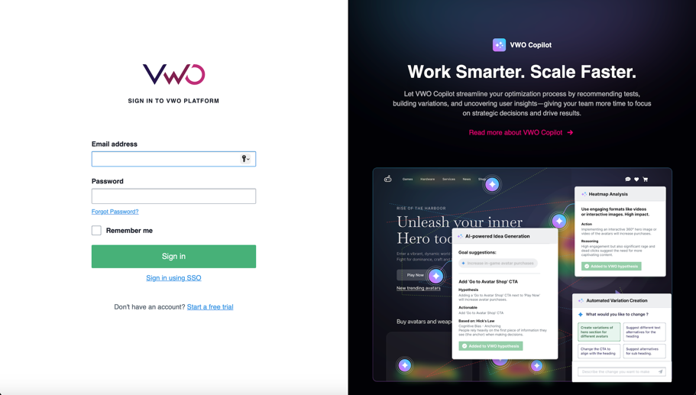

**Image 2**: Screenshot of the **SSO Login Page**.

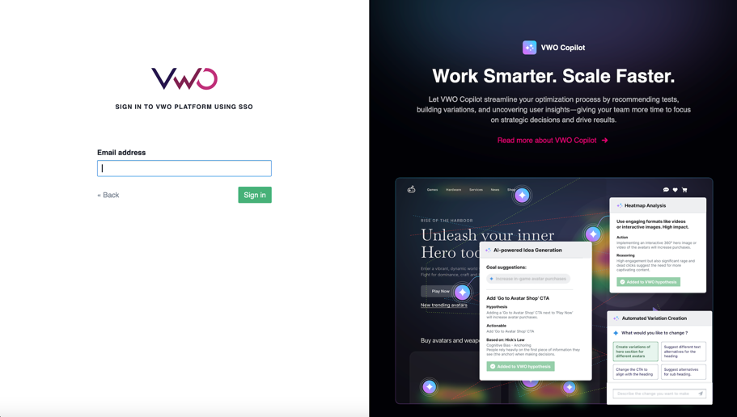

**Image 3**: Screenshot of the **Initial Registration Page** (Business Email step).

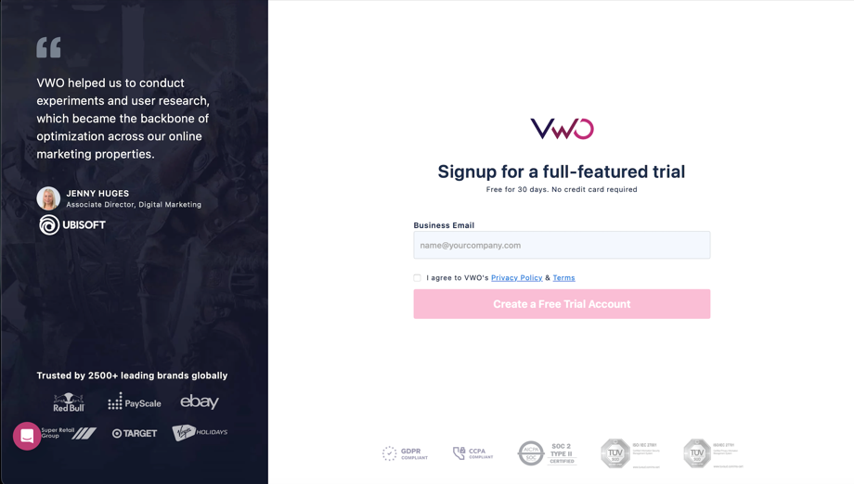

**Image 4**: Screenshot of the **Detailed Registration Form**.

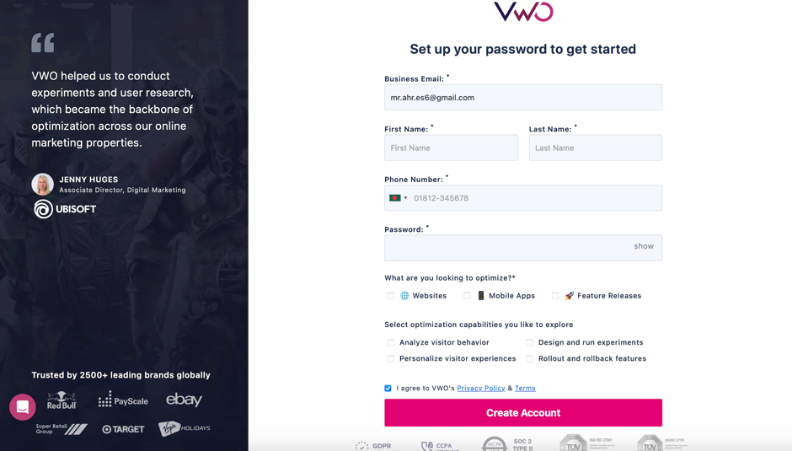

### ****5. Security Requirements****

* **Input Validation**: All input fields must be validated on the client and server sides to prevent SQL injection, XSS, and other security vulnerabilities.
* **Password Encryption**: All user passwords must be encrypted before being stored in the database.
* **HTTPS**: All data must be transmitted over **HTTPS** to ensure the privacy and integrity of the user data.

### ****6. Performance Requirements****

* The **Login, SSO Login, and Registration Pages** should load within **3 seconds** on average.
* User actions such as clicking **Sign In** or **Create Account** should trigger responses within **2 seconds**.

### ****7. Compatibility Requirements****

* The system must be **compatible** with the latest versions of major web browsers, including:
  + **Google Chrome**
  + **Mozilla Firefox**
  + **Apple Safari**
  + **Microsoft Edge**
* The system must be **responsive** and work on both desktop and mobile devices.